**2: YAML Basics Introduction**

--- Reference - [**https://github.com/stacksimplify/kubernetes-fundamentals**](https://github.com/stacksimplify/kubernetes-fundamentals)

--- Reference - [**https://github.com/stacksimplify/kubernetes-fundamentals/tree/master/06-YAML-Basics**](https://github.com/stacksimplify/kubernetes-fundamentals/tree/master/06-YAML-Basics)

--- **note** – to write kubernetes yaml manifests, we need to have a little bit of knowledge on yaml scripting so we are going to look into few yaml basics.

**Yaml basics**

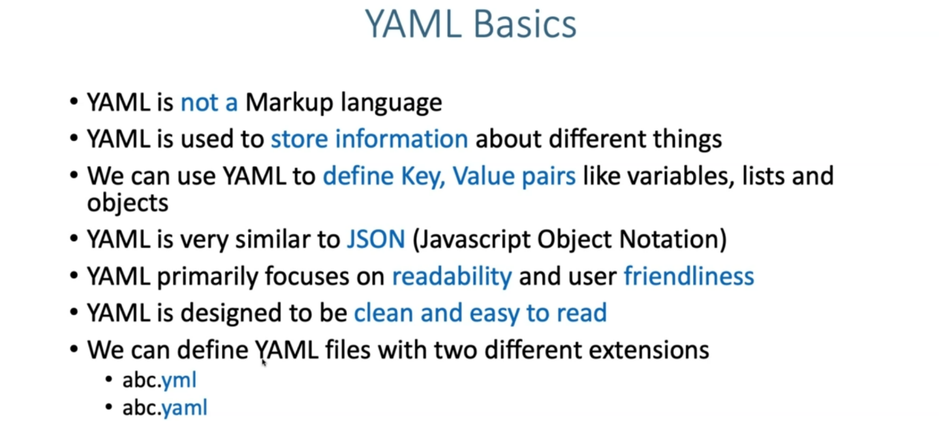

**Yaml core concepts**

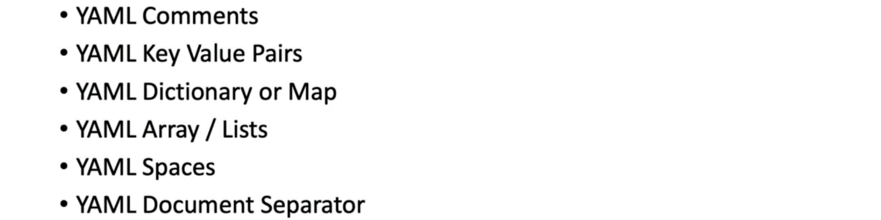

--- **note** – we will go and implement above topics.

**Comments & Key Value Pairs**

--- Space after colon is mandatory to differentiate key and value

# Defining simple key value pairs

name: kalyan

age: 23

city: Hyderabad

**Dictionary / Map**

--- Set of properties grouped together after an item

--- Equal amount of blank space required for all the items under a dictionary

person:

  name: kalyan

  age: 23

  city: Hyderabad

**Array / Lists**

--- Dash indicates an element of an array

person: # Dictionary

  name: kalyan

  age: 23

  city: Hyderabad

  hobbies: # List

    - cycling

    - cookines

  hobbies: [cycling, cooking]   # List with a differnt notation

**Multiple Lists**

--- Dash indicates an element of an array

person: # Dictionary

  name: kalyan

  age: 23

  city: Hyderabad

  hobbies: # List

    - cycling

    - cooking

  hobbies: [cycling, cooking]   # List with a differnt notation

  friends: #

    - name: friend1

      age: 22

    - name: friend2

      age: 25

**Sample Pod Template for Reference**

apiVersion: v1 # String

kind: Pod  # String

metadata: # Dictionary

  name: myapp-pod

  labels: # Dictionary

    app: myapp

spec:

  containers: # List

    - name: myapp

      image: stacksimplify/kubenginx:1.0.0

      ports:

        - containerPort: 80

          protocol: "TCP"

        - containerPort: 81

          protocol: "TCP

--- **note** - we can use “---” these dashes to separate the 2 documents in single yml file.